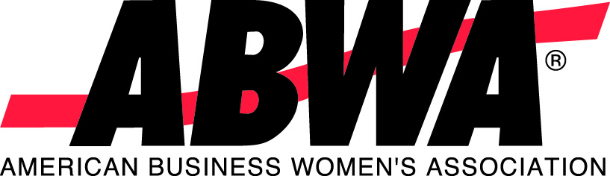
American Business Women’s Association
P.O. Box 4757 • Overland Park KS 66204-0757
(800) 228-0007 • Fax (913) 660-0101

Membership Application

Benefits of membership begin the date your application and payment are received and processed at ABWA National Headquarters. For renewal purposes, membership starts on the first day of the month following the date the application and payment are processed and renews annually. Dues payments are non-refundable and non-transferrable.

Date:

First Name: MI: Last Name:

Affiliation Information:
Do you plan to join a local league? Yes No If yes, league name:
Note: Participation in an ABWA local league is contingent upon timely payment of annual National dues.

Name of Member Sponsor (if applicable):

Address and Contact Information:

Home Address:

City / State / Zip:

Primary phone contact: Primary e-mail address:

Do you have a Facebook account: Yes No Facebook Name:

Note: An e-mail address is required to access your membership information and conduct business online at www.abwa.org. By providing your e-mail address, you are authorizing ABWA to contact you by e-mail.

Personal Demographics (for statistical purposes only):
Birthday (MM/DD): Birth Year (YYYY): Gender: Female Male
Business Owner, Employment and Education Level Demographics (for statistical purposes only):

Your Company’s Name: Your Title:

Are you a business owner? Yes No Description of products/services:

Highest Level of Education Completed:
High School/GED Vo-Tech Associate’s Degree Bachelor’s Degree Master’s Degree Doctorate Degree
Enclosed is my ABWA National dues payment of:
$115 ABWA National Membership $ 50 ABWA National Student Membership
*To qualify for student membership, include a class schedule reflecting enrollment in 12+ credit hours per semester.

Payment Information: € Check: Mail check with application to ABWA, P.O. Box 4757, Overland Park, KS 66204-0757
€ Visa € MasterCard € Discover # / / /

Expiration Date: / Security Code (3-digit code on back of card):

Name on Card: Signature:

The American Business Women’s Association is a non-profit organization which is serviced by ABWA Management, LLC, a company organized for profit. All ABWA income is received by ABWA Management, LLC and, in exchange, the company provides all necessary services and materials to the ABWA membership. All dues include a one-year subscription to Women in Business®, ABWA’s official publication. Dues are not deductible as a charitable contribution for Federal income tax purposes; however, they may be deductible under other provision of the Internal Revenue Code.

